Practice 1 – Basics of working with the interface of Cisco equipment. Remote connection to network equipment.

Student name: Ishutin Nikolay
Student ID: 24B031822
Group: Friday 12:00-14:00 Room 438

Topology
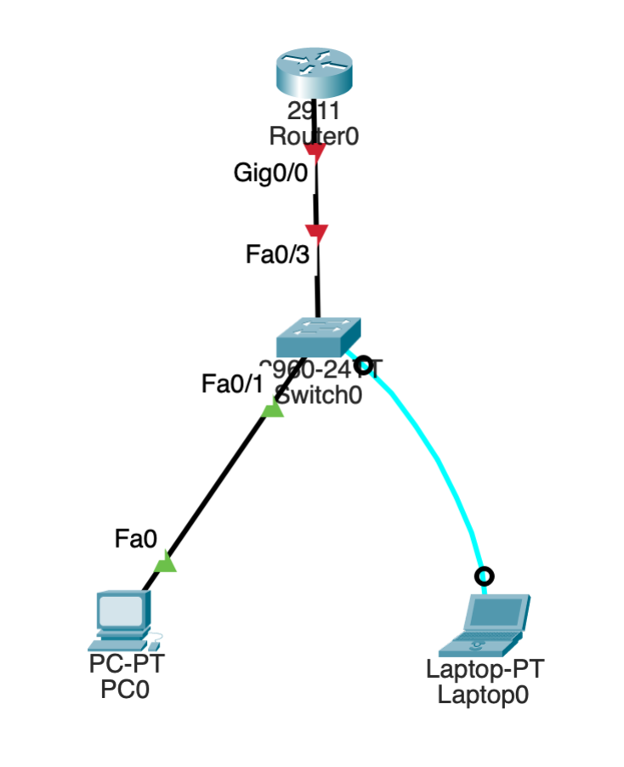

Requirements
● Software: Cisco Packet Tracer installed on your system.
● Devices: Ensure you have a PC, a Laptop, a Cisco 2911 Router and a Cisco 2960 Switch in your workspace.
● Cables: Use a console cable for a direct connection and straight-through cables.

Background
In this activity, you will introduce the Cisco IOS, including different user access modes, various configuration modes, configuring IP addresses, setting up remote connections, and creating users.

Introduction
In this practical work, the basics of working with Cisco network equipment and the Cisco IOS interface were studied. The main goal of the laboratory work was to become familiar with different user access modes, configuration modes, and basic device configuration using. During the work, 2960 switch and 2911 router were configured. Console and remote connections were established, passwords and user accounts were created, IP addresses were assigned, and network connectivity was tested. This practical task helped us to understand the principles of secure access to network devices and the basic steps required for configuring network equipment.

Solution steps

1. Placed the laptop and Switch 2960 in the work area
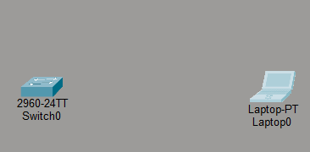

2. I connected the switch and laptop using a console cable. The laptop has an RS-232 port, and the switch has a console port.
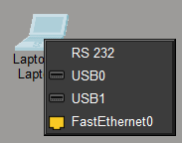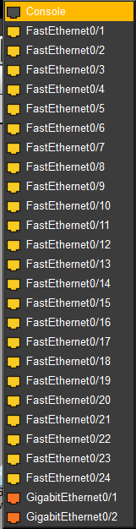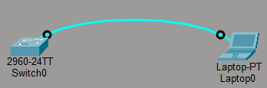

3. I clicked on the laptop, went to the "Desktop" tab, and clicked "Terminal." In the window that opened, I confirmed the terminal settings and logged into the terminal.

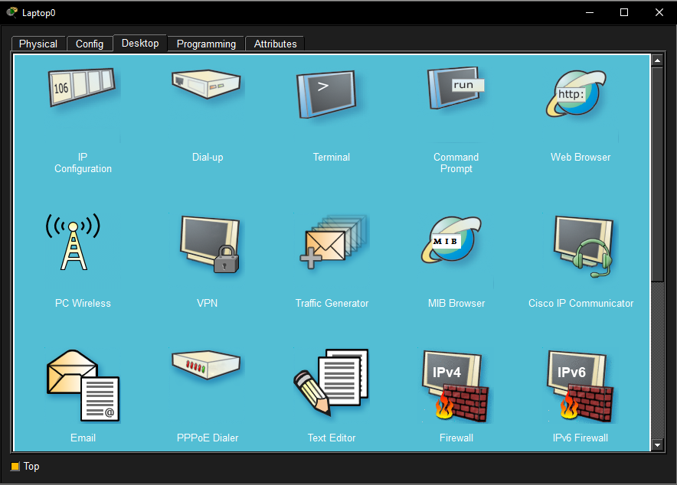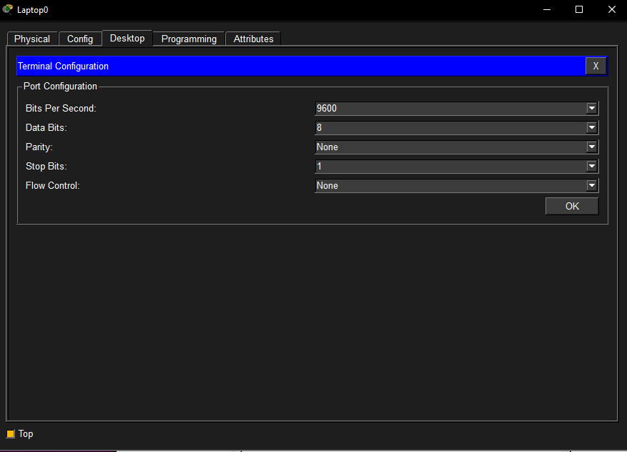
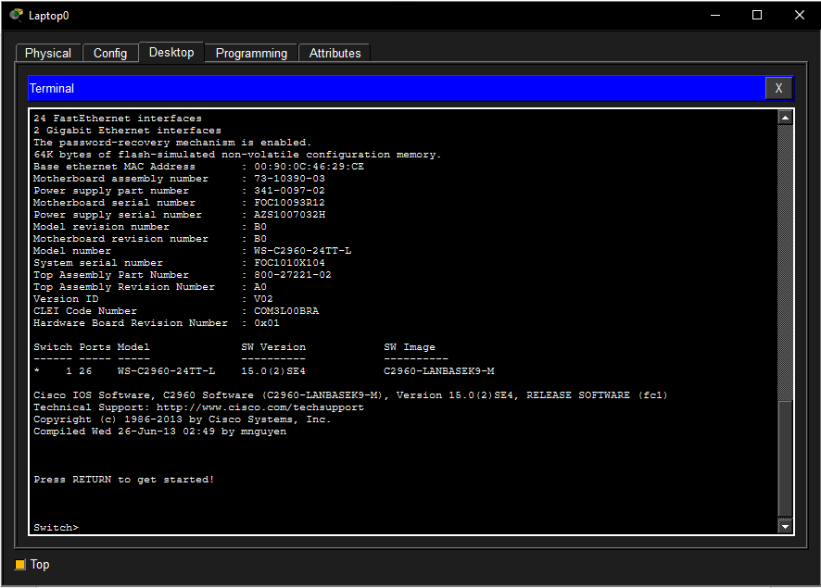

4. I typed "enable" and switched to Privileged Mode, which is marked with a #. To exit the mode, type "exit." Then I switched to Global Configuration Mode. Then I changed the switch name to "NikolaySwitch" and added a banner saying "#This is Nikolay's switch. You need to authorize to the system!". Switched to user mode by entering "exit" and checked the banner.
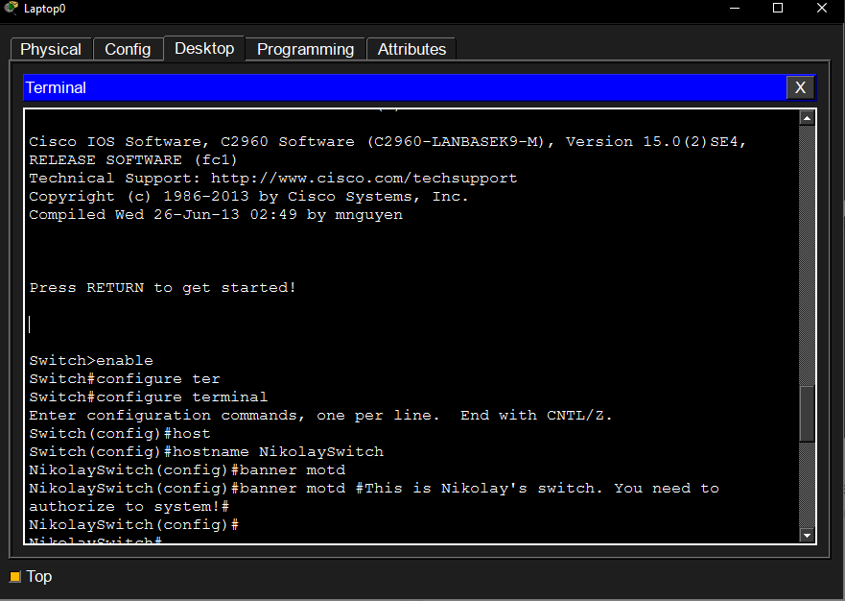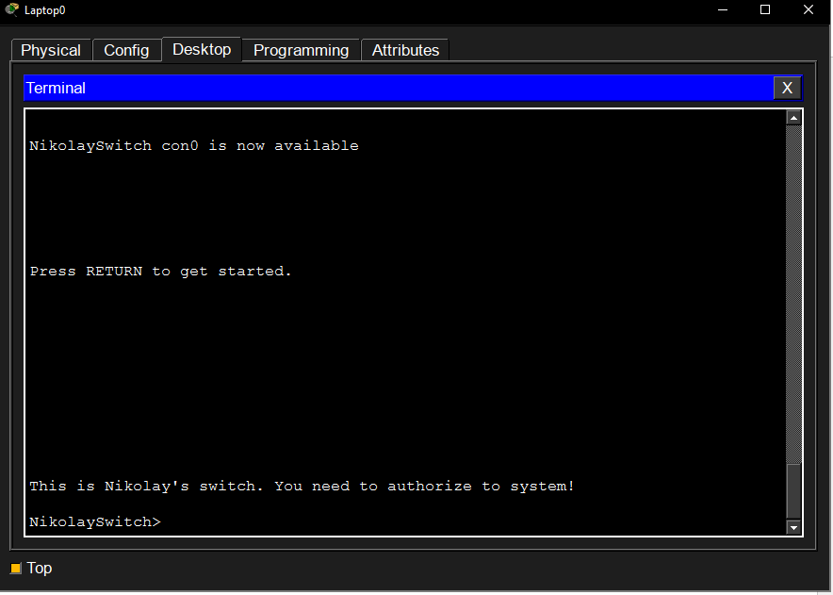

5. To set the password, I went into Global Configuration Mode and entered the command enable password «24B031822». I also entered the encrypted password using enable secret «enc24B031822». I exited Global Configuration Mode and verified the settings using showrunning-config. Then I went back into Global Configuration Mode and encrypted the password using service password-encryption. I also checked in Privileged Mode and saw that the password was encrypted.
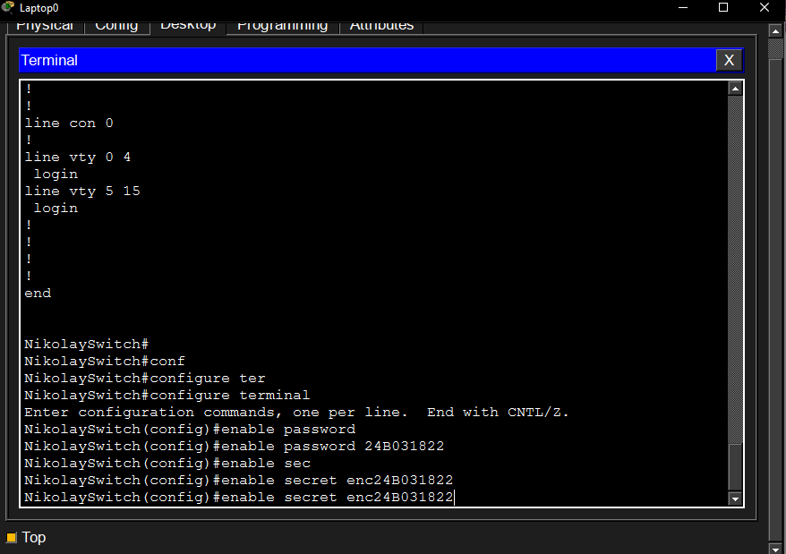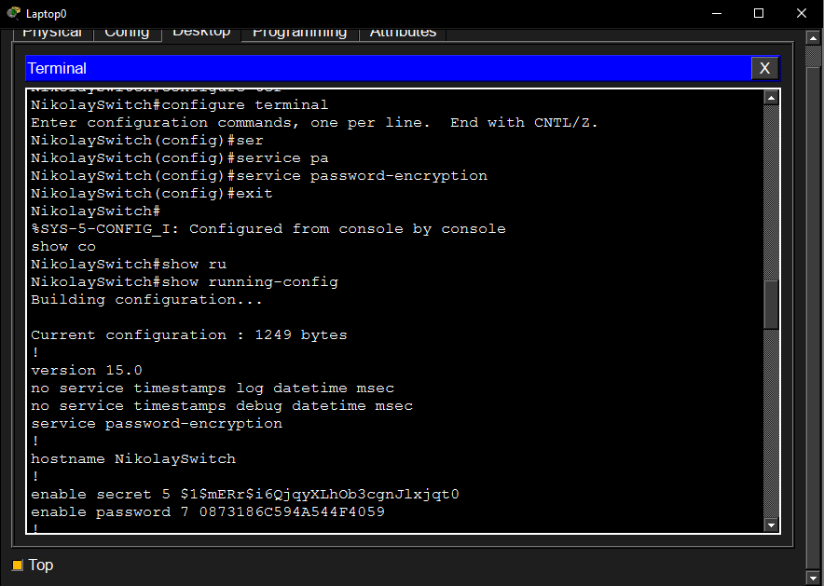

6. Now I need to create a password to log into the console. I go to Global Configuration Mode and enter "line console 0," which takes me to the console settings. Next, I enter "password 24B031822" and then "login" to prompt the console for a password. Next, I exit config-line and create a user. I enter "username Ishutin privilege 15 password cisco." 15 means the highest level of control. Now I'll configure a remote connection to the console, that is, Telnet. In Global Configuration Mode, I enter "line vty 0 4" and then "login local" to require user authentication when logging into Telnet. Then "transport input telnet" to configure remote access. After setting it up, I go into Privileged Mode and type show running-config to check if everything is installed correctly.

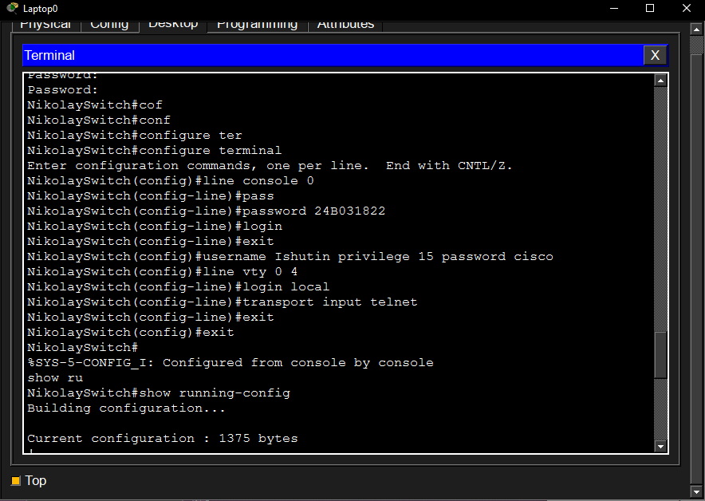 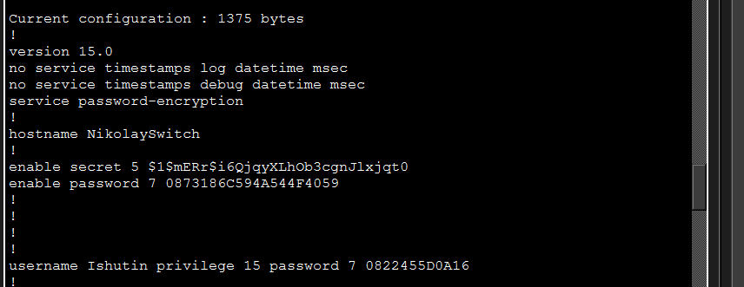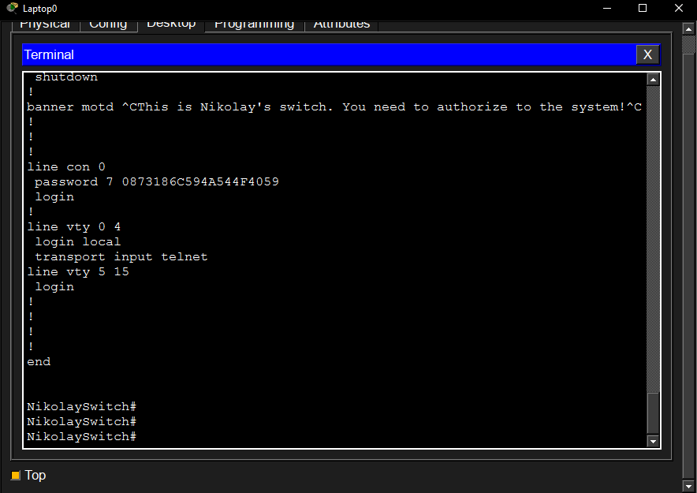\

7. Next, I'll configure the IP address for the switch. I'll go to the VLAN interface in Global Configuration Mode using the "interface Vlan1" command, then enter "ip address 192.168.0.5 255.255.255.0," and enable the interface using the "no shutdown" command. Now I need to save the settings to NVRAM so they're used when the switch boots. In Privileged Mode, I enter "show startup-config" and see that there are no saved settings. Then I enter "copy running-config startup-config," which copies the settings from running-config to startup-config, saving the settings to NVRAM. I check with "show startup-config" and see that the settings are saved.
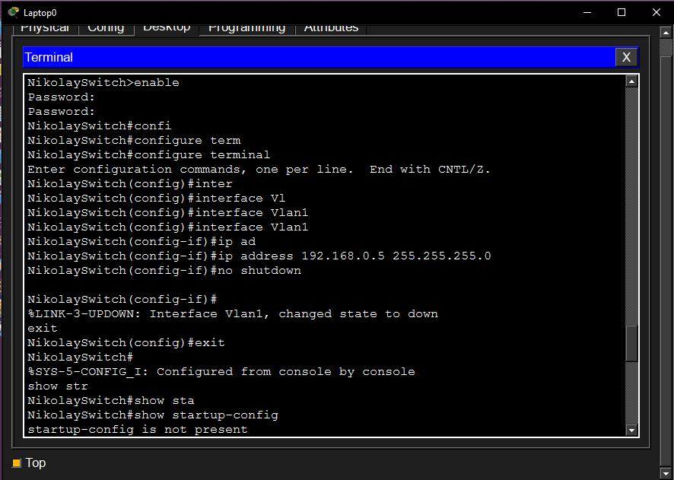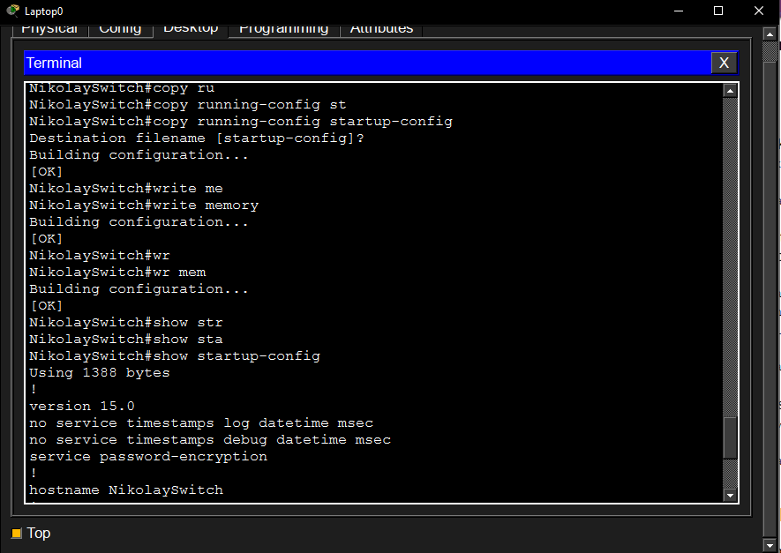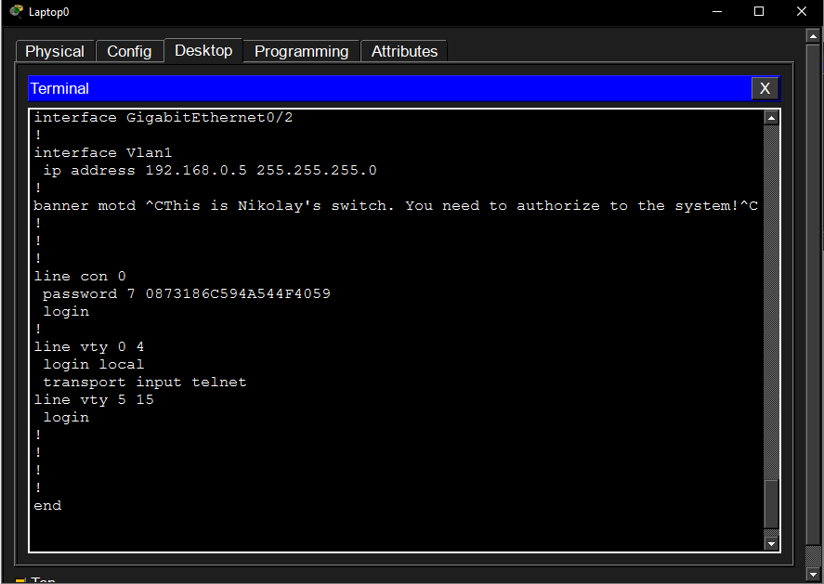

8. Now I need to test the connection between the devices. I drag the PC into the workspace and click on it, go to desktop -> Ip configuration and enter 192.168.0.2 in the IPv4 address line. Now I need to test the connection between the PC and the switch. I click on the PC and go to the desktop -> command prompt and enter "ping 192.168.0.5" to confirm the connection is established. Next, I need to test remote access. I enter telnet 192.168.0.5 and then enter user: Ishutin password: cisco and also confirm that remote access is working.
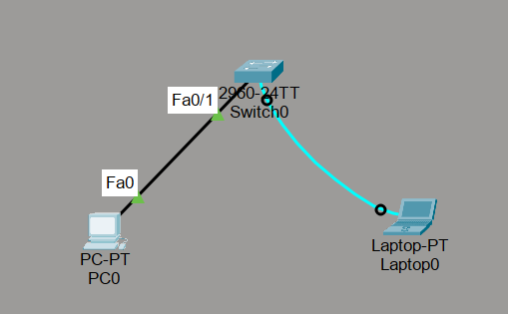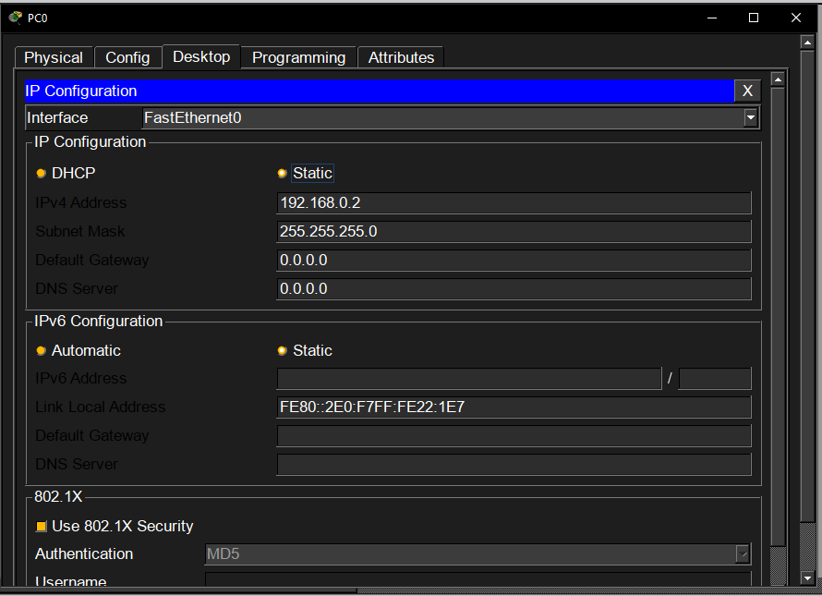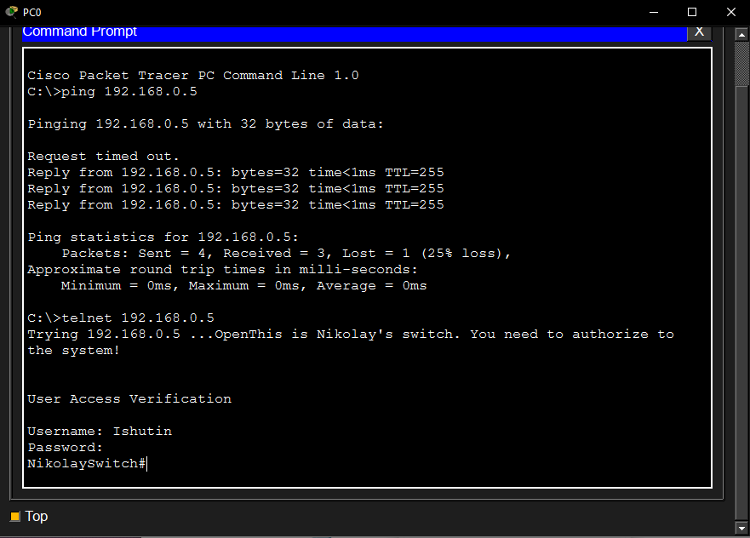

9. Next, I needed to configure the router. First, I dragged the 2911 router into the work area, connected it to the laptop (the router has a console port, the laptop has an RS-232 port), and opened the terminal by clicking on the laptop. The console asked, "Would you like to enter the initial configuration dialog? [yes/no]: ", and I answered no. Just like in the switch, I switch to Privileged Mode and then to Global Configuration Mode with the commands "enable" and "configure terminal". Just like on the switch, I'm starting the setup process. 1) I change the name of the router "hostname NikolayRouter" 2) I set the password "enable password 24B031822" 3) I set a warning message before logging in "banner motd #This is Nikolai's switch. You need to authorize to the system!#" 4) Encrypt the passwords "service password-encryption" 5) Set the encrypted password "enable secret enc24B031822" 6) Go to the console setting "line console 0" and set the password that will be required when logging into the console "password 24B031822" and at the end enter "login" so that the password is requested. 7) I exit Global Configuration Mode to Privileged Mode and create the user "username Ishutin privilege 15 password cisco"
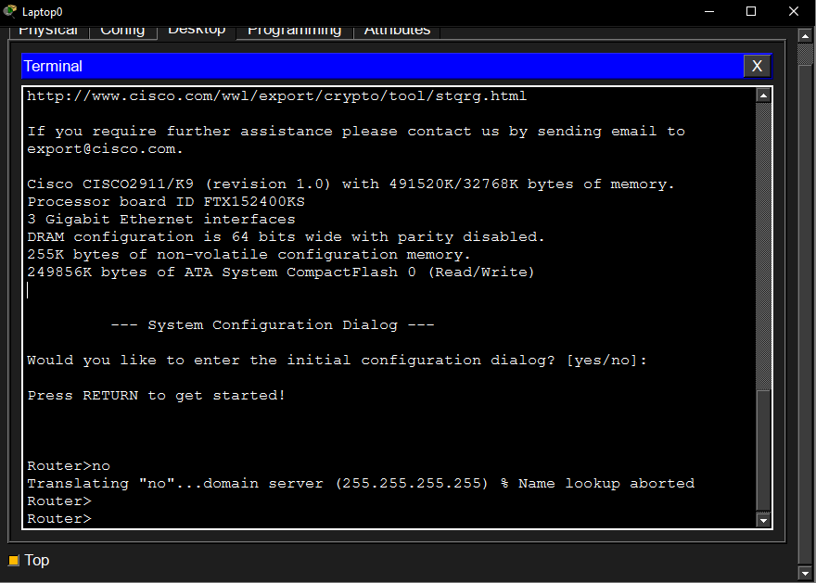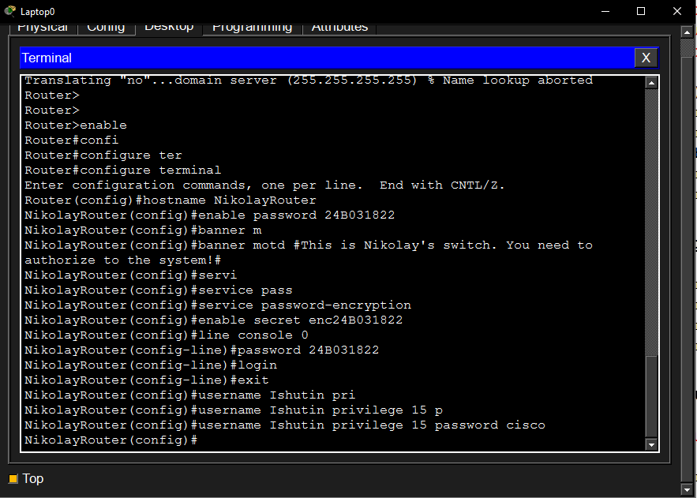

10. Next, I need to configure the network interface so that you can connect to the router. I enter the command "show ip interface brief" and I can see all the network interfaces of the router. Next, I switch to Global Configuration Mode and enter the command "interface GigabitEthernet0/0" to configure this interface. I enter "ip address 192.168.0.1 255.255.255.0", thereby setting up the IP address for the ethernet interface and then turning it on with the "no shutdown" command. I exit the interface settings and switch to the remote access setting "line vty 0 4". I turn on the "login local" authentication and activate the "transport input telnet". I exit Global Configuration Mode and check the settings. I also enter the command "show ip interface brief" and check the interface. I save all the settings by entering the "write memory" command.
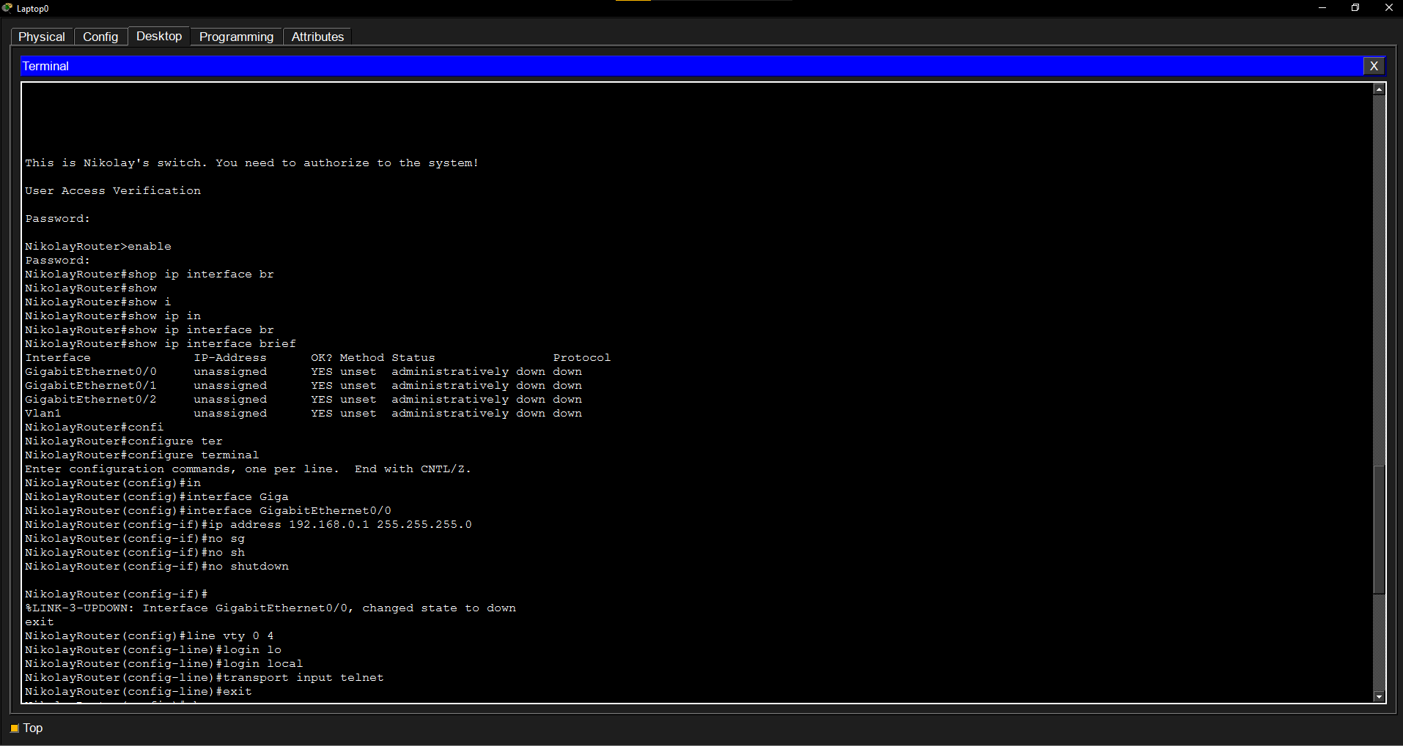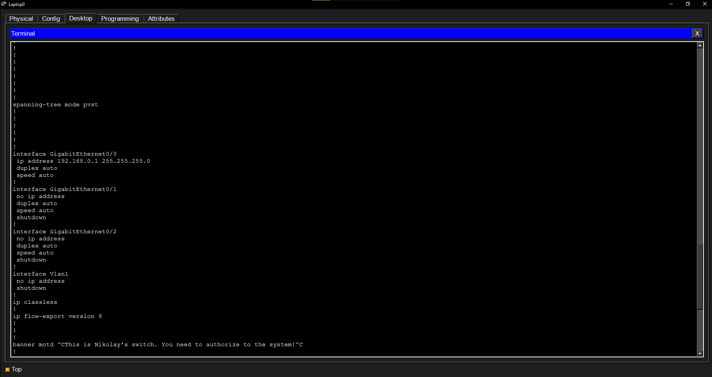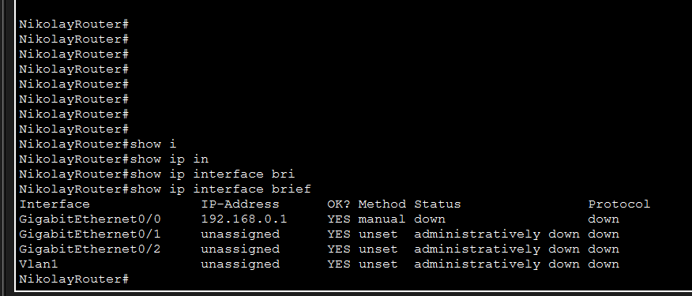

11. Now I'm checking the connection between the computer and the router. I connected the wires between the switch and the router and used the command in the computer's "command prompt" "ping 192.168.0.1". There is a connection between the computer and the router and everything is working correctly. Now I'm trying to connect remote access via "telnet 192.168.0.1". I successfully connect and enter the user's data.
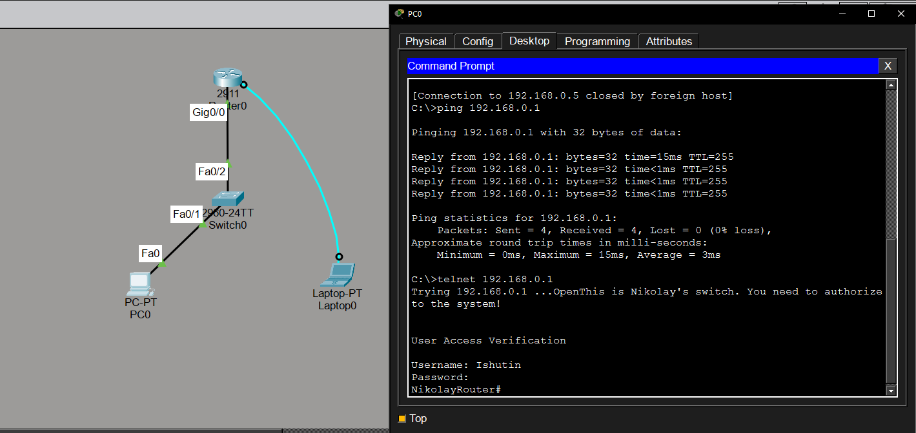

Key Questions:

1. What steps are required to move from User Mode to Privileged Mode on a Cisco switch?
We need to enter the "enable" command in the terminal.

2. What is the difference between the enable password and enable secret commands when configuring access?
The enable password command stores the password in plain text and is less secure, while enable secret encrypts the password and has higher priority.

3. Which commands are needed to configure an IP address on the VLAN1 interface and activate it? Provide an example.
In Global Configuration Mode using the "interface Vlan1" command, then entering "ip address 192.168.0.5 255.255.255.0," and enabling the interface using the "no shutdown" command.

4. What is the difference between startup-config and running-config? Which command is used to save the configuration from running-config to startup-config?
In running-config, all settings are stored in VRAM memory, which may not be saved when the device is restarted.
The show startup-config command displays the configuration stored in NVRAM (Non-Volatile RAM) that will be loaded when the device boots up.
We can use copy running-config startup-config or write memory or shortly wr mem to save the configuration from running-config to startup-config.

Conclusion
As a result of this practical work, the basic skills of configuring Cisco network equipment were successfully developed. The Cisco IOS interface was explored, and the process of switching between different access and configuration modes was practiced. Password protection, user authentication, and remote access using Telnet were configured on both the switch and the router. IP addresses were assigned to the switch and router interfaces, and network connectivity was tested using ping and Telnet commands. All configured devices operated correctly, and successful communication between the network components was confirmed. This work provided practical experience that is essential for understanding and managing networks.

